Return to Sport

Workbook

June 6, 2020

Contents
Acknowledgement 3
Preparation 4
Overview 4
Your Responsibilities 4
Phased Reopening 4
Focus of Phase I 5
Materials to collect to help with completing this workbook: 6
How to Use this Document 6
Administration 7
Program Insurance 7
Participant Waivers 7
Organization 8
Range Layout and Capacity 8
Bathrooms 9
Participant Factors 9
Age and Ability to Comply to New Rules 9
At Risk populations 9
Scheduling 9
Booking and Record Keeping 10
Cleaning 11
Signage 11
Use of Personal Protective Equipment (PPE) 12
Equipment Sharing 12
Other Areas to Plan 13
Communications Plan 14
Staff/Coaches/Volunteers Communications Plan 14
Participant Communication Plan 14
Range Procedures 16
Screening Questions 16
Safety Briefing 16
Athlete Use of Hand Sanitizer 17
In-Practice Monitoring 17
Sign In and Sign Out 17
Appendix A: Sample Waiver 18
Appendix B: Example Range Layout using Excel 19
Set your working grid 19
Overall Layout 19
Specify Zones 19
Appendix C-1: Sample Sign in Sheet 20
Appendix C-2: Sample Sign in Sheet 21
Appendix D: Sample Participant Notice 22
Appendix E: Cleaning in Public Places 23
Appendix F: Range Setup 25
Appendix G: Single Target Shooting Line 26
Appendix H: Double Target Shooting Line 27
Appendix I: Trap and Skeet Shooting 31
Appendix J: Silhouette Target Shooting 33
Appendix K: Sample Signage 34

Acknowledgement
This document was developed with the assistance of the BC Target Sports Association and the BC Archery Association.

Preparation

Overview
Target Shooting is an individual sport and as such is well suited to early reintroduction into our communities. By its nature, it is often social, but has much of the required Physical Distancing built into the sport already.
Specific precautions will be needed pre- and post-practice to ensure safety is maintained, and minor changes are required to ensure physical distancing on the Target Shooting Line is planned for and enforced.
This workbook has been created to help clubs consider any COVID-19 protocols that may need to be implemented in order to ensure our participants and volunteers can practice in a safe environment. This applies if you are creating your plan or just refining your current plan.
This workbook should be used in conjunction with the BCTSA Return to Sport Plan and the published viaSport Guidelines. Those Guidelines and the BC Target Sports Return to Play Plan can be found on our website (http://www.BCTSA.bc.ca).

Your Responsibilities
As leaders in sport in BC, it is up to us to implement these orders and recommendations in our specific environments. It is important that clubs do not rush into starting activities again, even though there may pressure from the members to do so. It is essential to get all the protocols in place before activity resumes and ensure that everyone in your club or organization are on the same page. Not only are our Athletes depending on us to keep them safe, but the public as a whole is still at risk, and should any major outbreaks occur we will revert to more stringent restrictions. If we are found to be a focus of an outbreak, we may see our sport singled out provincially to prevent any reoccurrence.

Phased Reopening
On May 6th, the government announced a phased re-opening of the province, including re-opening sport. But there are restrictions and limitations. The government has published it’s plan, and it’s requirements (https://www2.gov.bc.ca/gov/content/safety/emergency-preparedness-response-recovery/covid-19-provincial-support/bc-restart-plan). The following is taken from the BC Restart Plan:
- Stay at home if you have any symptoms: Coughing, Sneezing , Runny nose, Sore throat, Fatigue
- Good Personal Hygiene including:
  - Regular hand washing, including before and after practice
  - Avoiding touching your face
  - Covering coughs and sneezes
- No travel, local business only
- If you are at greater risk (over the age of 60 or with underlying medical conditions), be informed of your risk, think through your risk tolerance and take extra precautions.
- Limits to numbers: no more than 50.
  - Gathering restrictions apply to each separate space e.g. an outdoor range that can be managed separately with suitable physical distancing between these spaces.
  - Care must be taken to avoid interacting at communal points such as entries and car parks
  - In personal settings when you are seeing friends and family who do not live with you: Only get together in small groups of around 2 to 6 people and keep a physical distance
- Physical Distancing: 2 meters
- Enhanced Cleaning, including
  - Clean “high-touch” areas frequently and provide hand sanitizer at entrances
  - Disinfect frequently touched surfaces and shared equipment
    - For recreation activities where equipment is unable to be sanitised, for example ropes, a withholding period could be considered to allow any virus particles on these surfaces to die (e.g. 120 hours between uses).
- Provisions for Contact Tracing must be in place: Contact tracing register for all participants and spectators must be in place and able to be accessed quickly
- Enhanced Controls:
  - Engineering controls – physical barriers or increased ventilation
  - Administrative controls – clear rules and guidelines
  - Personal protective equipment – like the use of non-medical masks
  - Implement strategies that reduce the number and intensity of contacts – from greater use of non-medical masks to more checkouts and increased shopping hours
Additional measures specific to various organizational settings are being developed. More will be created as various sectors are engaged and industry or sector wide norms are adopted and required.
There are also additional materials at:
- BC COVID-19 Go-Forward Management Strategy
- BC COVID-19 Go-Forward Management Checklist

Focus of Phase I
The first phase of reopening the sport will be:
- Community based – participation will only be in your home community
  - Travel should be restricted to venues close to home. Attendees “from away” should be discouraged.
- Practice and Skill based. Competition will be introduced in future Phases.
  - Avoid participation that may lead to larger than anticipated gatherings. Leagues, match-play, score-based activity that produces a winner at the end should not be encouraged at this time. Small club competitions involving local competitors are acceptable as long as clubs take measures to minimize Covid risk.
  - In-Club competition or modified games may slowly be introduced.

Materials to collect to help with completing this workbook:
Collect the following to aid in your planning:
- Insurance Documentation
- Current Waiver
- Building and Range layout and dimensions, as available

How to Use this Document
This document is laid out to cover:
- General Issues
- Range Layouts and Capacity
- Scheduling, booking and other planning issues
- Range Operation
Work from start to end, as the later material builds on the earlier material in many cases.

Administration

Program Insurance
Each club will need to review their insurance policies and evaluate their risk. Regardless of the date of policy renewal, there is likely no liability coverage for COVID-19 related claims. COVID-19 is viewed as a Risk Management issue rather than an insurance issue. Any reopening of the sport venue should be carefully tailored to the circumstances of each club, considering all aspects covered in this plan, and that the plan is rigorously followed.
What are your insurance concerns and follow up needed?

Participant Waivers
Participant waivers may need to be updated. Consider an acknowledgement that COVID transmission is a risk, agreement to follow all rules, and a statement indicating that the participant and anyone accompanying them are symptom- and risk-free. The waiver should be signed before participating. See a Sample Waiver in Appendix A.
Disclaimer: there is conflicting advice around the inclusion of COVID-19 as a potential risk in Target Shooting. It is best if each club confer with their insurer to determine what works best for their situation.
How will you handle participant waivers?

Organization

Range Layout and Capacity
Range Layout will depend on the specific activities to be carried out. A drafting program, or spreadsheet such as Microsoft Excel can help, or you can just draw it out on paper. See Appendix B for more information on using Excel to draft your Range Layouts.
You will need to lay out your ranges to determine your capacity.
Basic rules are:
- Allow 1 metre for each Target Shooting lane and 2 metres between lanes. This means that each Target lane takes up 3 metres. Dimensions may vary slightly depending on lane width for specific Target Shooting sports.
- At some venues, it is possible to run a double line where 2 groups of Athletes take turns Target Shooting, but it takes more space behind the Target Shooting line and is more complicated. See the appendix and lay out the space very carefully.
- Allow room, as necessary, for equipment, spectators, sign-in and other functions. This may be in the range area, or outside of it, depending on your venue’s space availability.
Complete the layout of all ranges and public areas you will be using:

What other areas will be accessible to Athletes, Spectators and the Public? Will there be separate areas for waiting, sign in, sign out, set up, etc.? List the areas that need to be planned:

These also need to be mapped out. Ensure there is room for both 2-meter distancing and the required movement. Document how you will organize the spaces and what signage will be necessary.
Recheck that:
- all required areas and functions are accounted for
- you included Gun Racks and club equipment
- that everyone can maintain 2-meter distancing
- That while moving from place to place, 2-meter distancing is still possible
- That there is room for staff/coach/volunteer movement
* | When laying out the Range, remove all unnecessary equipment, and ensure everything in public areas is easy to disinfect, or protected.

Bathrooms
What is your plan for Physical Distancing? What is the maximum capacity for each? For example, if your range uses outhouses, will you provide signage for where to stand 2m back while waiting to use the outhouse? If your washrooms have more than one stall, how will you ensure physical distancing requirements while standing at the sinks?

Participant Factors

Age and Ability to Comply to New Rules
The age and ability to comply with the rules and the behavior of participants will be considered when planning range capacity and use. You may need to consider whether you exclude participation by young athletes if they are not able to understand the new rules, or restrict the number allowed to participate in each session when a parent/guardian needs to also be in attendance. Parents/Guardians need to be counted in the group capacity calculations.

At Risk populations
The elderly, those with chronic disease and the immunocompromised are at higher risk. Will you need to exclude these groups, or are there accommodations that can be made?
What is your plan for your different participants?

How will you handle spectators? None allowed? Physical Distancing?

Scheduling
One of the first decisions that will need to be made is how to schedule range and practice time.
For Phase I of Return to Play, Drop-Ins are not allowed. All attendance must be booked in advance. This is necessary in order to avoid overcapacity and distancing problems while waiting. Physical distancing rules will decrease range capacity by up to 2/3.
Adequate time for arrivals and departures, without 2 groups being present at the same time, must be considered. Generally, 30 minutes between groups should allow adequate time for:
- the departure of the current group
- required cleaning
- the arrival of the next group
In addition, cleaning, sign-in and other factors may alter the timing of range availability.
Enter Range times, activity types and capacity you expect can be offered at your venue:
Range | Time | Activity Type | Capacity

Booking and Record Keeping
All practices must be pre-registered. There are many ways you can do this, from informal phone calls or email, using Google Forms, to commercial programs such as SuperSaas. Consider how this reservation information will be shared with your administration to ensure you know who will be at the range at each time, and allowing you to monitor, to the best of your ability, that only those with reserved space is utilizing the venue.
Choose your method of Pre-registration. Describe how it will work:

In addition, attendance records must be kept allowing for Contact Tracing, should an outbreak occur. With pre-booking, this is relatively easy if:
- contact information is included in the booking,
- attendance is taken at the practice, including arrival and departure times
- Spectators are registered either with the pre-booking or at the practice
- A list of all staff/coaches/volunteer’s present is kept
Outline how you are going to facilitate the collection of attendance information for Contact Tracing purposes:

Sample sign in sheets are included in the Appendix.

Cleaning
Prevention of COVID transmission requires additional precautions and cleaning.
Cleaning will need to include general cleaning of common areas but also additional cleaning of high touch areas. It is best to minimize these areas, where possible.
Identify all “High Touch Areas” in each of your Zones (first 2 columns):
Cleaning
Zone | High Touch Area | When | How
All | Floors | Daily or as needed | Sweep
All | Flat Surfaces | Between each Practice | Sanitized Wipe
All | Doorknobs | Between each Practice  During high Traffic | Sanitized Wipe  Every 10 min
All | Commonly touched areas | Between each Practice  During high Traffic | Sanitized Wipe  Every 10 min
Bathrooms | Counters and sinks cleaned | Between each Practice
Bathrooms | Floors | Daily or as needed | Sweep
Bathrooms | Toilets | Daily or as needed | Sanitized
All | Locks | At beginning and end of session | Sanitized Wipe or spray

Be sure you have included bathrooms, out houses, waiting areas, doors, tables, targets, markers, etc.
Now go back, and specify how, and when you will clean these areas. The BCCDC handout in Appendix E can help.

Signage
What signs do you need:
- to help people find you
- at the entrance to the facility
- at the range
- at various zones you have identified (sign-in, waiting, spectator, set up, etc.)
At the very least, there needs to be signage indicating:
- Stay away if ill
- Maintain physical distancing
- Wash/sanitize your hands
Sample signs can be found in the Appendix.
What signs do you need, and where should they be placed?

Use of Personal Protective Equipment (PPE)
What rules will you put in place for use of PPE by Athletes?

By Spectators?

By Staff/Coaches/Volunteers?

Equipment Sharing
Sharing of equipment needs to be minimized. There is shared club equipment, such as target backers, gun racks, etc. that need to continue to be shared. There is also personal equipment that Clubs will often loan out. Short term loan (day-use) of this equipment needs to be minimized, and only for items that can be easily sanitized. In all cases, longer term (months) loan is preferred over single practice loan.
Porous items, and items that cannot be easily sanitized will not be loaned.
What is your plan for sharing and sanitizing your equipment? Some of these items are listed, and you will need to add others, according to your club’s needs:
Item | Period | Sanitization Plan | When
Target Backers | Practice | Spray with bleach | Before practice  After practice
Guns | 3+ months | wipe | On return
Gun Racks | Practice | Wipe | Before practice  After practice
Mats | Practice | Wipe | Before practice  After practice
Kneeling Rolls | Practice | Wipe | Before practice  After practice
Offhand Stands | Practice | Wipe | Before practice  After practice
Silhouette Targets | Practice | Paint or spray with bleach | Before practice  After practice

Other Areas to Plan
Consider if any other areas need specific changes or plans to ensure participant and staff safety:
- Parking
- Drop off and pick up
- Waiting area for rides
- Staff Areas, Lunchrooms, etc.
Outline the area and any changes you need in these areas:

Communications Plan
For your plan to work, all those involved need to understand the plan and their roles in executing it.

Staff/Coaches/Volunteers Communications Plan
How will you inform and train your staff?

Participant Communication Plan
How will you communicate various aspects of the plan to your participants? This will likely involve multiple communications to them.
How will you communicate the re-opening and general rules? Draft that communication here:

If not done above, how will you announce the opening of registrations?

How will you describe the registration procedures? For example, in addition to instructions on how to register, will there be a sign at the range informing those that did not pre-register to please return home and follow the registration procedure?

How will you communicate the expectations of participants? What equipment must they now bring themselves? Who supplies Hand Sanitizer, Water, Sanitizing wipes, masks, gloves, pens (for the sign-in book)?

See the Sample Letter to Participants in Appendix D

Range Procedures

Screening Questions
All Staff, including coaches, will be asked screening questions before interacting with each other or the participants.
Prior to any Athlete participating, the group (including spectators) will be canvassed, as part of the safety briefing to ensure no one is symptomatic or at high risk. Should an Athlete reveal that they are symptomatic or high risk, they will immediately be removed from the group, distanced from the group, and advised to wear a facemask until they can return home.
The screening questions will be:
Does anyone in the group:
- Feel unwell?
- Have a cough or cold?
- Have a Fever?
- Been in contact with someone who is known to have COVID-19 in the last 14 days?
These questions may also be included in any waiver or sign in process, but needs to include spectators, as well as athletes.

Safety Briefing
COVID precautions require changes to physical distancing, movement of Athletes, use of shared equipment and areas or zone of use.
There is generally a safety briefing at the beginning of all practices. How will this change with COVID precautions?
If your venue does not utilize safety briefings / formal practice sessions, how will you communicate the necessary information to the participants/users?
In addition to the standard Safety Briefing, COVID Specific protocols will be explained, including
- Sign In and Sign Out for Contact Tracing
- No one with COVID symptoms or contact allowed (Screening Questions)
- 2 meter distancing
- Use of PPE and Sanitizers
- Movement patterns during Target Shooting

Athlete Use of Hand Sanitizer
What are your policies regarding PPE and Hand Sanitizer?
- All Athletes will bring Hand Sanitizer and Sanitizing Wipes to Practice
- Athletes will use Hand Sanitizer after touching any target, Target Backer or common equipment

In-Practice Monitoring
These new procedures do not come naturally to many of us who have developed our own “habits” on the range. Similarly, new Athletes will need help remembering the new procedures. What plan do you have for monitoring and correcting gaps in process?

Sign In and Sign Out
In order to track contacts, participants and spectators must sign in when they arrive, and sign out when they leave. How will you accomplish this?

Appendix A: Sample Waiver

Acknowledgement of Risk & Waiver

This form is to be signed by all club members & also by a parent / guardian if a member is a youth

As with many sports there exists with Target Shooting an inherent risk of accident which may cause material loss or bodily injury. It is a condition of membership of ___________________________ Club that all members acknowledge & accept these risks & sign this waiver / release of liability.

In agreeing to allow myself / child / ward to partake in the activities of ___________________________ Club I fully acknowledge & accept that risks exist & that I on behalf of myself or as a parent / guardian accept these risks. I am fully aware of the possible risks involved in the sport of Target Shooting, and I agree to myself / my child / my ward partaking in the sport of Target Shooting. I am aware that I am encouraged to request any further information as I may feel is necessary to allow me to make an informed judgment as to the inherent risks.

Activity | Risks (may include but are not limited to)
Target Shooting | Possible death or other injury, including bruising, muscle damage, fatigue or strain, damage to eyesight. The action or inaction of other persons. Sunburn or other weather-related risks. Accident caused by inattention, or equipment failure. (if appropriate, add: Risk of contracting COVID-19 while participating in Target Shooting activities.)
I further understand & agree that:
The physical demands of the sport of Target Shooting require that I / my child / my ward be physically fit & able to participate in the club’s activities. I accept the assertion that instructors reserve the right to refuse me / my child / my ward to participate in the club activities for any reason.
To assist in instruction, it may be necessary on occasion for instructors to have limited physical contact with me, my child / ward.

Please advise any medical condition / allergy you / your child may have – in the unlikely event of an accident medical personnel may require this information.

Medical Conditions / Allergies: ____________________________________________________

- I confirm that I have read the above and fully understand & freely accept the type of activity that I / my child / my ward will be participating in, and the inherent risks associated with those activities.
- I freely accept responsibility for myself / my child / my ward & agree to hold harmless & free of blame ___________________________ Club, its Officers, Directors, Coaches & assistants.
- I waive my right to institute legal action associated with bodily injury occasioned whilst engaged in club activities against ___________________________ Club. Its Officers, Directors, Coaches & assistants.
- I accept that this waiver & release is binding upon me & upon my heirs, next of kin, executors, administrators, personal representatives & assigns.
- I sign & accept this waiver & release voluntarily & without pressure.
- I hereby agree to myself / my child / my ward taking part in Target Shooting activities associated with ___________________________ Club.
- I have read the athletes code of conduct and understand that my membership may be terminated at the discretion of the ___________________________ club board members should I fail to follow this code of conduct.

Signature of Participant:_______________________Print Name:___________________________

(If participant is under 18)
Signature of Parent / Guardian:________________________Print Name: ________________________

Dated: (day) _______ (month) ___________ 20___

Appendix B: Example Range Layout using Excel

Set your working grid
To use Excel to draft your Range Layouts, open a new worksheet, and set a working grid by:
- Select All (Ctrl-A)
- Set Row Height to 24
- Set Row Width to 4
This should give you a roughly square grid to work from. Adjust, as necessary.

Overall Layout
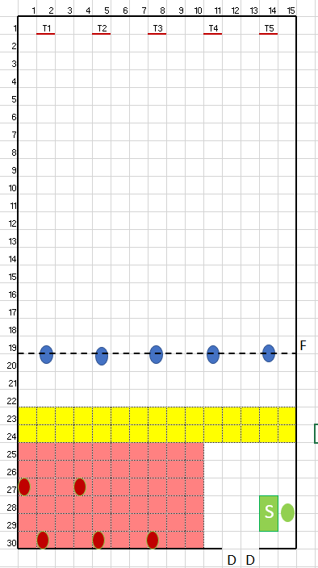
Outline your boundaries with doors, gates, etc. Use Insert -> Shapes to choose lines, boxes, circles, etc. Place your Target lines, Target Shooting Lines and other features to scale on the grid. Within “Shape Format” you can choose “Snap to Grid” to make your lines run on exact grid points or turn it off to place off the grid points. You can choose line width, color, pattern, fill, etc.
Some preferences:
- Boundaries work well as lines.
- Tables and chairs work as solid rectangles.
- I like ovals for people positions.
- For actual people in position, I like a circle with no fill, but a wide colored outline.

Specify Zones
You can outline different zones by selecting the cells and changing the background color (easiest if working to grid boundaries) or putting down a rectangle. Different zones might include:
- Target Shooting
- Waiting
- Spectator
- Sign In
- Equipment Set up
In this example we are using a 1 meter grid, Target Shooting Positions are blue ovals, Targets T1-T5 are red lines (2 pt wide), There is a green Sign-in table with a person behind it, a red Spectator Zone with 5 spectator chairs and a Yellow Equipment Setup zone.

Appendix C-1: Sample Sign in Sheet

Club |  | Location
Event |  | Date
Start Time |  | End Time
Staff Present
Name | Membership Number | Email | Phone

Athletes Present:
Name | Membership Number | Email | Phone

Spectators Present:
Name | Email | Phone

Notes:

Appendix C-2: Sample Sign in Sheet

Club Name:

This information is being collected to assist in the management of the COVID-19 pandemic.
It will be given to the Ministry of Health and/or Regional Health Authority on request if it is required for contact tracing purposes.
We will not use it for any other purpose and will destroy this record after four weeks. It will be kept in a safe and secure location in the meantime.
Date | Full Name | Address | Email | Phone | Time in | Time out

Appendix D: Sample Participant Notice
We are all anxious to get back to Target Shooting. We now have permission to do so, but we will need to take precautions to make sure everyone is safe. As a shooting sport, we always keep safety as our priority. Starting up again, with COVID in the community, is no different.
A Phased approach to reopening our sport will limit group size, maintain Physical Distancing, and minimize physical contact. Initially, we will focus on Practice and skill development, not competition.
Changes you will see are:
- Do not come to the range is you are sick, or have any of the following symptoms:
  - Feeling unwell
  - Fever
  - Cough
  - Cold
  - Travel or contact with someone thought to have COVID in the past 14 days
- No drop-ins. Everyone must pre-register.
- Everyone must Sign In before starting practice. You will be assigned your lane at this time.
- You must keep at least 2 meters distance between you to anyone else.
- There will be no sharing of equipment between Athletes during a practice session.
- Use of club equipment will be limited to that which we can easily clean. You must wipe down, both before and after the session:
  - Your mat, if shooting prone
  - Your Rifle or Pistol, including magazines
  - Offhand Stands
  - Kneeling rolls
  - Any table or Bench
  - Any Target Shooting Aids
  - Any chairs used
- You must bring your own:
  - Eye Protection
  - Ear Protection
  - Hand Sanitizer
  - Pen
- Only 1 spectator will be allowed per Athlete, and only in the designated areas, capacity permitting
- Movement and distancing while Target Shooting will be discussed during the safety briefing. These instructions must be strictly followed.
- You will be required to arrive and depart the range promptly. We will not be able to accommodate latecomers, and because of occupancy restrictions, you cannot remain at the range once you are finished Target Shooting.
- Any violation of these rules will result in you being asked to leave the range. This is a safety issue for you and everyone around you.
None of these new rules will affect our enjoyment of our sport. They are intended to keep us safe and get us back Target Shooting as soon as we safely can.

Appendix E: Cleaning in Public Places
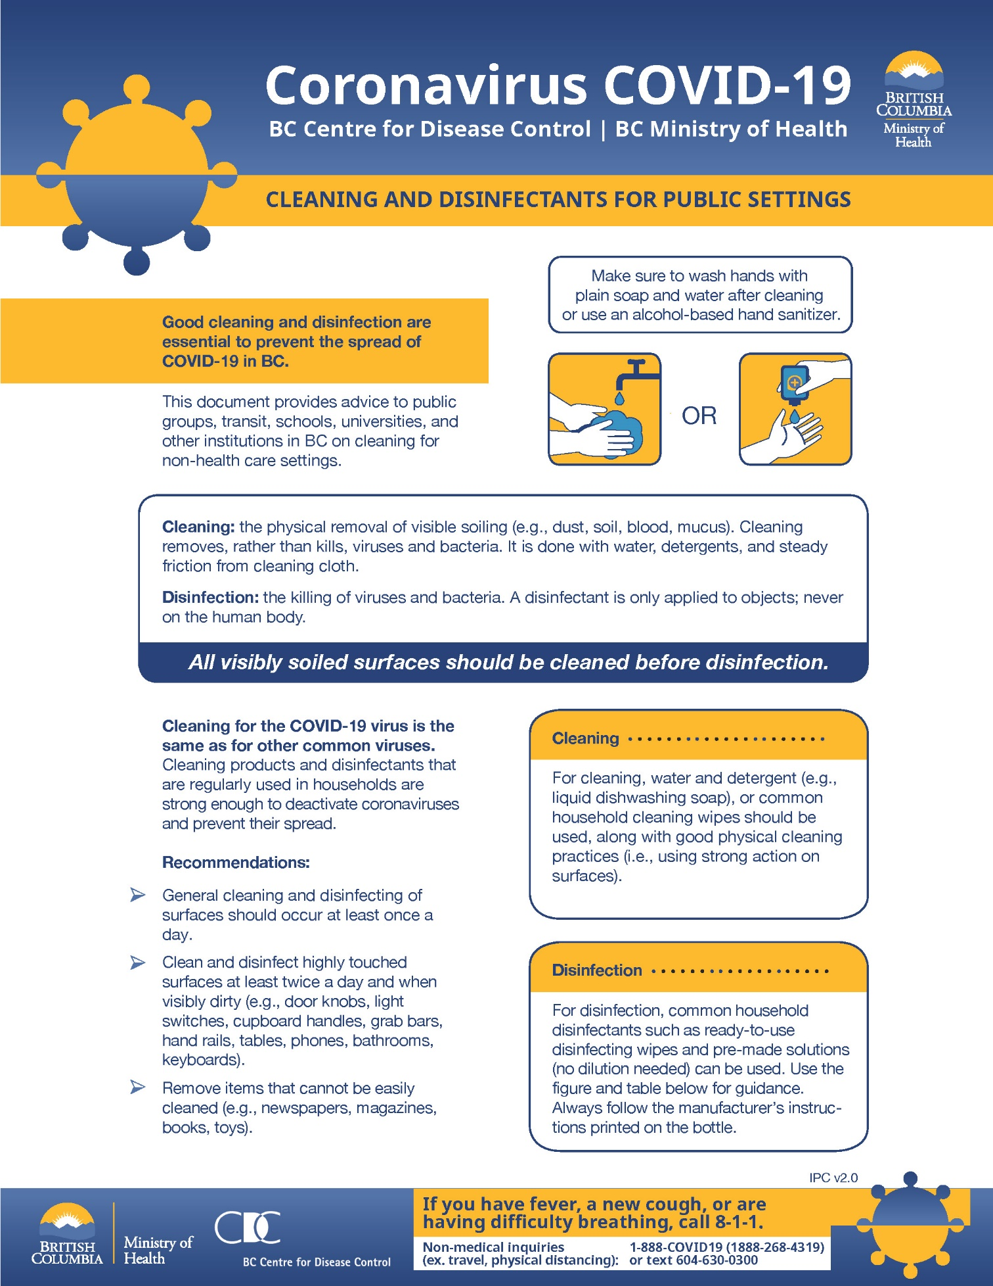

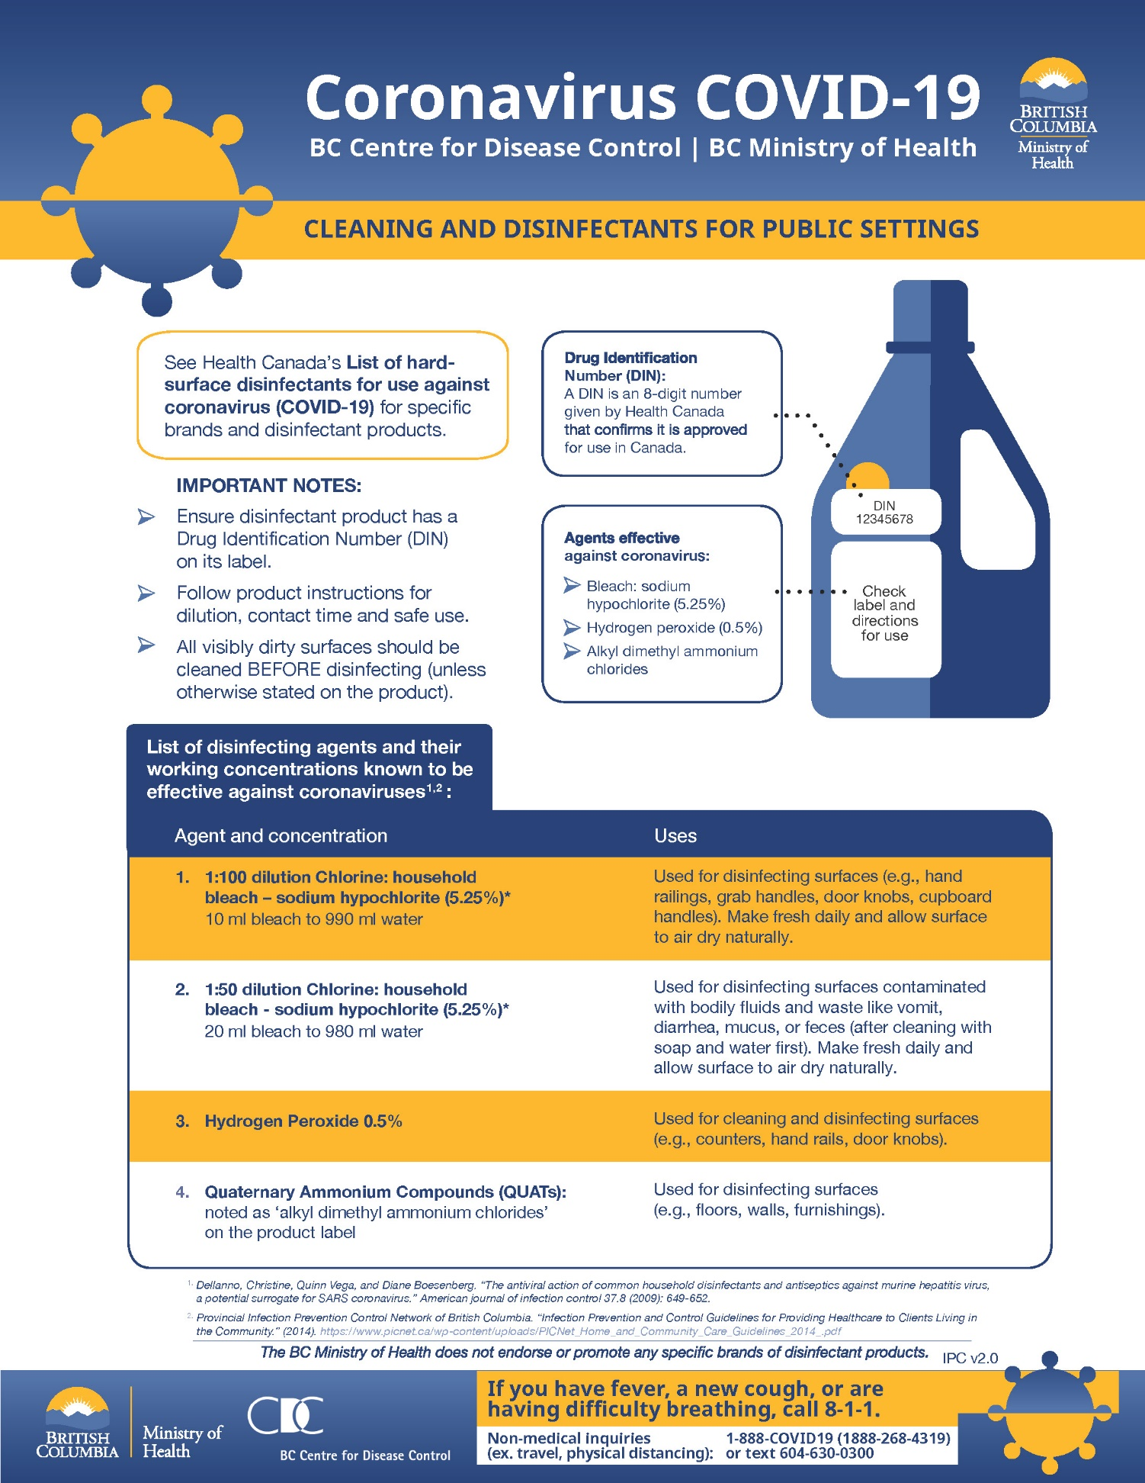

Appendix F: Range Setup
The Range is split into a downrange area consisting of:
Targets and Backers
Scoring Area
Downrange Waiting
Range
Target Shooting Line
Athletes Area
Uprange Waiting
Distancing
Spectator Area, if any
- Targets and Backers
- A Scoring Area
- A downrange Waiting Area
This corresponds to a similar area up-range that operates similarly:
- Target Shooting Line
- Athletes Area
- Up-range Waiting
The Downrange waiting and up-range waiting areas only come into play if running 2 lines. This is the area where the non-shooting Athlete waits.
The Spectator area, if any, is distanced from the Athletes as appropriate to the Venue.

Appendix G: Single Target Shooting Line
If operating with a single line of Athletes, the Up-range and Down-range waiting areas are not needed. Athletes are to be assigned to their lanes and remain within the space provided.
Target Shooting lanes should be 1m wide and space 2m apart. This places the Target Shooting lanes at 3m center to center.
For a single Target Shooting line of Athletes, the Target Shooting line looks like:
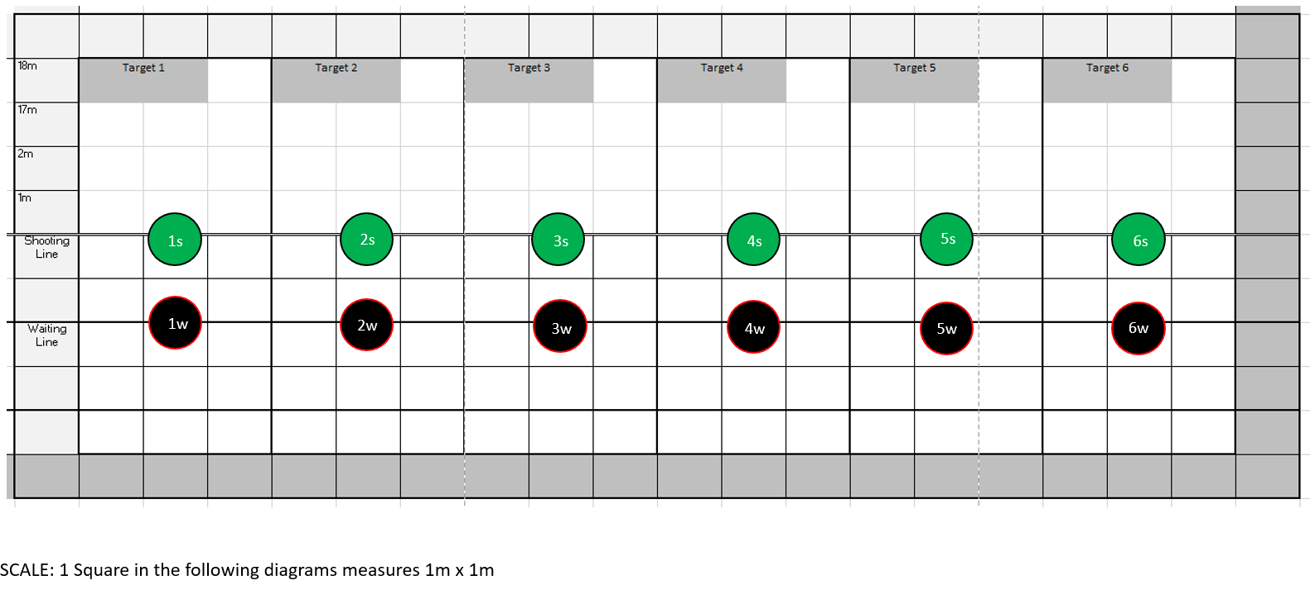
When run as a single Target Shooting line, the Athlete moves between their assigned Target Shooting position on the line, and the associated waiting position behind the line, using standard line control protocol. No additional signaling is required.
Similarly, when scoring, no changes need to be made for Physical Distancing, beyond what is done at the Target Shooting Line.

Appendix H: Double Target Shooting Line

Running a double line adds complexity to managing the line but allows approximately 2/3 of the number of Athletes that could be accommodated on a single line pre-COVID. For a double Target Shooting line, the lane setup will be the same as a single line but when operating in a double line, athletes will need to move to specific locations within the range and their Target Shooting line in order to maintain a 2m personal distance at all times.
The following diagram shows the range layout. Each Target Lane will consist of:
  - Three (3) individual Target Shooting lanes measuring a minimum of 1m wide: “A” Target Shooting lane, “B” Target Shooting lane, and a Buffer/Safety Lane.
  - Two (2) Transition Positions; 2m behind the Target Shooting line on the left and right border of the Target Lane.
  - One (1) Waiting Position; 4m behind the Target Shooting line in the center of the Target Lane
Some Transition Positions will be shared between adjacent Target Lanes. Athletes will need to take care to move only when their next position is clear. If the next position is not clear, they need to hold in place for a moment until the position is vacated and then move when it is safe. The amount of time they will be holding will be very short because the Transition Positions will not be occupied for any extended periods of time until it is time to collect arrows.

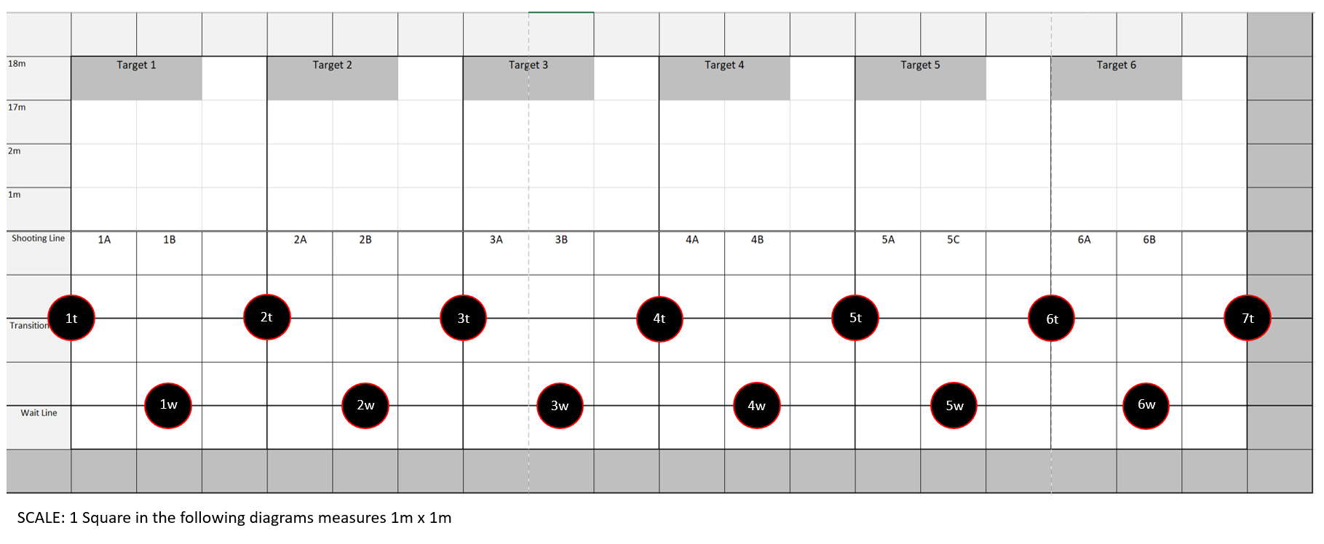

Target Shooting Procedure:
- Following Pre-Registration and before entering the field of play, athletes will be assigned a Target Lane (Number) and Target Shooting Lane (Letter).
- The following diagram shows the athletes in the “Ready to Shoot” position. This will indicate that the Range Officer can call the athletes to the line.

- Using standard protocol, the Range officer will call the Athletes to the line (2 whistles).
- Using standard protocol, the Range officer will signal that it is safe to shoot (1 whistle). Athlete A group will proceed to shoot their arrows.

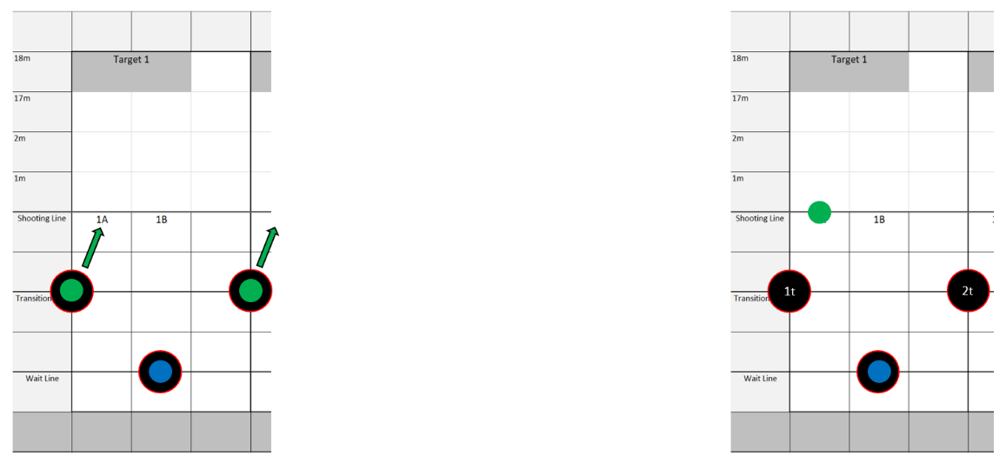
Note: To show movement as clearly as possible, the following diagrams will show only one Target Shooting lane.
- Athletes will finish Target Shooting at different times. As each Athlete is done Target Shooting, they will check to see if their designated Transition Position is clear. If it is clear then proceed to their Transition Position, the Athlete may move and if it is not clear they will hold until it is clear to move. In this case, Athlete 1A can move to their Transition Position because it is unoccupied.
- Once Athlete 1A is in the Transition Position, Athlete 1B can proceed to their Transition Position.

- Once Athlete 1B has reached their Transition Position, Athlete 1A can move to the Waiting Position. Following proper Target Shooting etiquette, Athlete 1B can proceed to the Target Shooting Line immediately.
- Upon arriving at their Target Shooting Position, Athlete B can proceed to shoot their arrows.

- Once Athlete B is done Target Shooting, they will check to see if their designated Transition Position is clear. Athlete B can move to their Transition Position if the following conditions are met:
  - If the Transition Position is open
  - If Athlete B from the adjacent Target Shooting lane has is not waiting and has begun to shoot.

- Once all athletes are in the All Clear Position, the Range officer will signal that it is safe to collect arrows using standard protocol (3 whistles).
- Athletes will proceed to collect arrows. B Athletes will collect arrows first and A Athletes will collect after B Athletes are done. All Athletes must proceed through this phase maintaining 2m personal distance at all times.

An animation of this process is available at: https://youtu.be/RTcvmvOkFM4

Appendix I: Trap and Skeet Shooting
Trap Shooting can take place with no modification. Care will need to be taken to ensure physical distancing before, after and with cycling through the range. Common equipment (eg. trap House equipment and switches) will either be handled with gloves, wiped or sprayed between users.
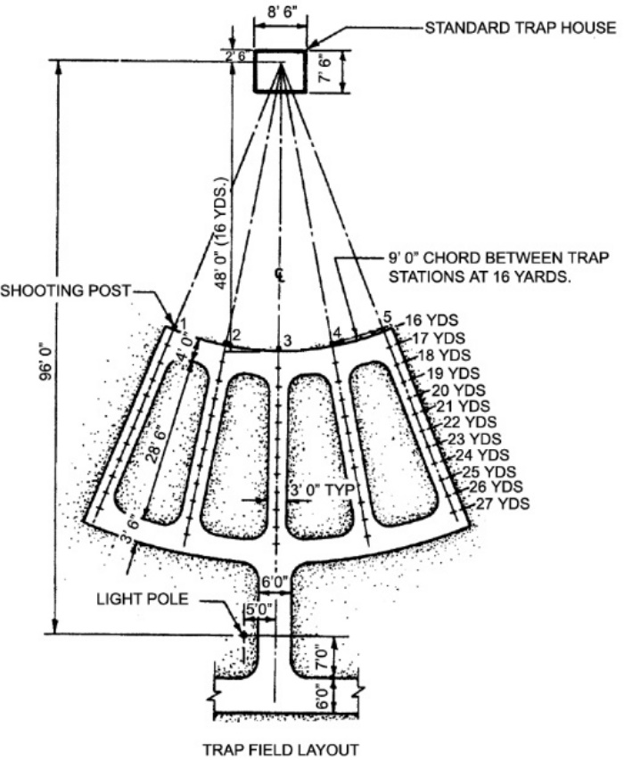
The Athletes are a minimum of 9’ apart at the 16-yard radius. This provides ample Physical Distancing.

Similarly, for Skeet, a single Athlete uses 8 stations. Adequate physical distancing is easily achieved:
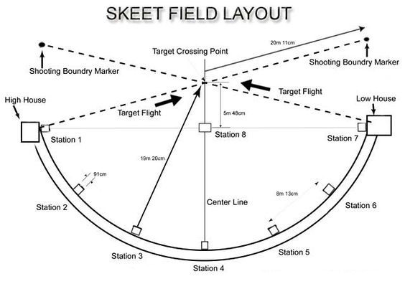

Appendix J: Silhouette Target Shooting
Silhouette Target Shooting follows the same procedures as target shooting. Accommodation for a spotter may be made, with the spotter keeping 2 meter distance from the Athletes – either directly behind the Athlete, or to one side, being careful of adjacent people.
A single line of Athletes is most appropriate (see Appendix G), as a double line will not work with the indicated spacing and spotters.
Silhouette Target Shooting usually involves multiple relays. Athletes awaiting their relay should social distance away from the firing line area. When possible, encourage one-way travel of Athletes and spotters when changing relays.
The flat bench area used as a firing point (e.g. to hold clip, timer, ammunition) should be disinfected once the Athlete leaves the firing line.
Try to minimize the number of people resetting targets at each distance (e.g. chickens, pigs, turkeys and rams). Target setters should wear gloves. It is recommended that targets be painted or sprayed with a dilute bleach solution or alcohol-based disinfectant between relays.
Consider adopting score keeping measures that minimize the spread of Covid 19. For example, only one person should post scores on scoreboard. Scorecards should be presented to the score keeper at the end of the match, rather than presenting scorekeeper with score cards at the end of each relay. Individuals handling score cards should wear gloves.
All equipment (e.g. rifles and spotting scopes) should be disinfected upon completion of the practice.

Appendix K: Sample Signage
The following pages contain samples of signage that can be used at your venue. Signs relevant to your venue can easily be created in Word or PhotoShop with a bit of creativity. Consider having signs professionally printed. Be sure to post signs in multiple locations, as determined by your answers in the previous pages.
A selection of physical distancing signs can be ordered from:
- https://www.bradycanada.ca/safety-signs/covid-19/social-distancing
- https://socialdistancingsignage.ca/
