Return to Sport

Rifle Target Shooting
Pistol Target Shooting
Silhouette Target Shooting
Trap Target Shooting

BC Target Sports Association
May 21, 2020

Contents
Acknowledgement 3
Overview 4
Focus of Phase I 4
Venue Access 5
Outdoor Ranges 5
Indoor Ranges 5
General Considerations 5
Access Control 5
Venue Arrivals and Departures 6
Sign in 6
Staging areas 6
Change Over of Athlete Groups 6
Occupancy Limits 6
Facility Operations 6
Staffing (Including Instructors, Range Officers, Volunteers) 6
Signage 7
Cleaning Procedures 7
Equipment Sharing 7
PPE Provision and use 8
Athletes 8
Bathroom and Facilities 8
Distancing measures 8
Availability 8
Suppliers and Contractors 8
Food Services 8
Cleaners 8
Participants 9
Health 9
Group Size 9
Age and Ability to Comply to New Rules 9
Spectators 9
Education, Communication of New Rules 9
Coaching 9
Observation 9
Intervention 9
Vulnerable Populations 9
Seniors 9
Chronic Illness 10
Rule Enforcement 10
Session Level 10
Club Level 10
Provincial Sport Organization (PSO) Level 10
Phase I Program Details 11
Activity Types 11
Equipment Use 11
Participant Cost 11
Program Insurance 11
Participant Waivers 11
Outbreak Response 11
Contact Tracing 11
Appendix A: General Range Setup 12
Appendix B: Target Range -- Single Target Target Shooting Line 13
Appendix C: Target Range -- Double Target Shooting Line 14
Appendix E: Silhouette Target Shooting 20
Appendix F-1: Sample Sign in Sheet 21
Appendix F-2: Sample Sign in Sheet 22
Appendix G: Sample Letter to Participants and Parents 23
Appendix H: Sample Waiver 24
Abbreviations 25

Acknowledgement
This document was developed with the assistance of the BC Target Sports Association and the BC Archery Association

Overview
Target Shooting, as an individual sport is well suited to early reintroduction into our communities. By its nature, it is often social, but with much of the Physical Distancing required built into the sport already.
Specific precautions will be needed pre- and post-practice to ensure safety is maintained, and minor changes are required to ensure physical distancing on the Target Shooting Line is planned for and enforced.

Focus of Phase I
The first phase of reopening the sport will be:
- Community based – participation will only be in your home community
- Practice and Skill based. Competition will be introduced in future Phases.

Venue Access
Both Indoor and outdoor venues are able to accommodate early return to sport, with proper planning and use. Some additional considerations are necessary for cleaning of indoor facilities.
Both Indoor and Outdoor Ranges must adhere to the basic Safety Requirements of the sport.

Outdoor Ranges
Normal Access and Safety considerations continue to be in force. No special changes are required in front of the Target Shooting Line, except for target access, which will be done in the same manner as access to the Target Shooting Line. (see details in the Appendices)
Access to the Target Shooting Line needs to be altered to allow for adequate distancing.
For Target Ranges there is the ability to run a double line while maintaining adequate distancing if there is enough room behind the Target Shooting line.
Those participants from the same family or share the same “bubble” may shoot at the same target without restriction of physical distancing on their target, while ensuring to follow the physical distancing protocols for those participating on other targets.

Indoor Ranges
Normal access and safety considerations continue to be in force. No special changes are required in front of the Target Shooting Line, except for target access, which will be done in a similar manner as access to the Target Shooting line.
Access to the Target Shooting line needs to be altered to allow for adequate distancing.
For Target Ranges there is the ability to run a double line while maintaining adequate distancing if there is enough room behind the Target Shooting line.
Those participants from the same family or share the same “bubble” may shoot at the same target without restriction of physical distancing on their target, while ensuring to follow the physical distancing protocols for those participating on other targets.

General Considerations

Access Control
By its nature, our sport limits access very strictly to ensure safety.
Access to the field in front of the Target Shooting Line is strictly controlled, with athletes, coaches and officials being the only ones allowed in front of the line, under normal procedures. All activity on the range must comply with the physical distancing measures and other recommendations and requirements issued by federal, provincial/territorial, and municipal authorities.
Access to the areas behind the Target Shooting line is also under a great deal of control; participants and spectators have separate areas.
In order to ensure no physical crowding of Athletes, Sign In and Staging must ensure occupancy rules are adhered to. Similarly, spectators, including parents and siblings, must be strictly controlled to ensure the safe capacity of the range is not exceeded.
Range access will be limited to a minimum number of individuals needed to complete essential tasks such as sanitization, sign-in, safety officers, coaches, officials, participants and guardians.
COVID-19 screening must be done by all individuals entering the range, including any volunteers, coaches, guardians, participants and officials. Screening will include visible and verbal checks of each individual.
Range access must be controlled at an access point and limited to only those who have pre-registered and are deemed low-risk by not outwardly showing any signs or symptoms of COVID-19 and have not been out of the province or country in the last 14 days.
Congregating in parking lots and common areas before and after range use must be monitored and discouraged.

Venue Arrivals and Departures
Whether an athlete is brought to the venue or travels on their own, an area and plan for arrival and departure is needed. The plan must consider ingress and egress of vehicles, Physical Distancing of occupants once leaving the vehicle, or while waiting for the vehicle to arrive.

Sign in
Practices must be by pre-registration. In the future, drop in may be allowed, but not at present. In either case, provision for sign in and assignment of Target Shooting lane must be organized in a manner that will protect both the Athlete and Staff and ensures occupancy limits are enforced.

Staging areas
Athletes waiting to participate, or those who have just finished will need staging areas to deal with equipment, personal effects and warm-up or cool-down routines. Physical Distancing and droplet protection must be addressed.

Change Over of Athlete Groups
The Change Over of one group of Athletes to the next could cause a double capacity problem to occur. Scheduling of space must allow adequate changeover time to avoid violating distancing rules. A minimum of 30 minutes is suggested, in order to allow time for arrivals, departures, warm-up, cool-down and equipment set-up and take-down.

Occupancy Limits
The number of people present in any single venue: indoor range, outdoor range, etc., including staff, participants and spectators will not exceed 50. However, this number must be reduced as needed to ensure adequate physical distancing depending on the limitations of the venue.
For this purpose, the venue will include Target Shooting areas, staging, equipment storage, spectator, staff and officials’ areas, and any other area associated with the practice or event.

Facility Operations

Staffing (Including Instructors, Range Officers, Volunteers)
If Staff have any symptoms suggestive of COVID or any other illness, they must not come to practices, or have any contact with Athletes, Spectators, parents or other staff.
Staff, including Coaching Staff, must be provided with adequate training to run and enforce these rules, as well as adequate Personal Protective Equipment (PPE) to allow then to remain safe and safely interact with Athletes.
There should not be any need for staff, including coaches, to violate Physical Distancing guidelines.
Any staff who are working directly with the public and Athletes, and are not separated by a protective barrier, will wear a facemask.
Staff will be responsible to ensure adequate cleaning is done and appropriate PPE is available to staff, Athletes and Spectators.

Signage
There will be signage at the entrance to any venue indicating the following:
- Requirement for physical distancing
- Prohibition from entering if symptomatic
- Copy of the Distancing rules and protocols for the specific venue
Each venue will be marked in such a way that:
- Lanes and Target Shooting positions are clearly marked
- Areas for staging, sign-up, storage, etc. are clearly identified
- Distancing points within these areas are clearly marked

Cleaning Procedures
Common surfaces and areas will need to be cleaned between groups of Athletes, with surfaces wiped down with antiseptic or covered with a clean cover.
Cleaning products must be designated as effective for both bacteria and virus.
The cleaning schedule will include:
Floors | Swept | Daily, or as needed
Flat Surfaces | Wiped | Between each practice session
Equipment | Wiped | Between each practice session
Doorknobs | Wiped | Regularly (every 10 min), while people entering or leaving
Commonly touched areas | Wiped | Between each practice, and as needed  If high traffic, every 10 minutes or more
Bathrooms | Counters and sinks cleaned | Between each practice
Bathrooms | Floors | Daily, or as needed
Bathrooms | Toilets | Daily, or as needed

Equipment Sharing
Athletes generally have their own equipment and will be advised to not share that equipment with others.
Any common equipment such as gun racks, targets, target backers will be wiped down with antiseptic, or sprayed with a bleach solution, between sessions.
Shooting mats will be made of non-porous materials and wiped with antiseptic between practice sessions. They will not be shared between Athletes during a training session. Similarly, any other common equipment such as rests, offhand stands and kneeling rolls will not be shared between Athletes during a training session and will be wiped down with antiseptic between sessions.
Renting of equipment should be discouraged, but if necessary, only after ensuring that appropriate sanitizing measures have been taken. No porous equipment (eg. Mats made of porous material, slings, leather goods) will be shared.
All items that cannot be easily cleaned will be removed from ranges, if possible.

PPE Provision and use
Where there is a need to touch common areas, such as target backers, Antiseptic Hand Sanitizer, wipes and/or gloves will be provided.
While face mask use by Athletes will not generally be required, they may optionally be used.

Athletes
Athletes will maintain physical distancing of no less than 2m at all times. They will be required to use appropriate PPE and Hand Sanitizer as needed. They will be responsible for wiping down their equipment, any club-owned equipment and any targets or range equipment both before and after use.

Bathroom and Facilities

Distancing measures
Occupancy limits of Bathrooms and other facilities will be posted and limited to ensure that adequate distancing is possible.

Availability
In order to ensure adequate Bathroom facilities are available, Athlete numbers may need to be limited, or resources increased.
The use of outhouses must include a distancing and cleaning plan.

Suppliers and Contractors

Food Services
Food Service is normally only provided during competition. Therefore, any food or coffee service should be suspended until competition (in Phase II) commences. If it is provided, Food Service providers must follow the current public Health guidelines, and enough space must be provided to allow adequate Physical Distancing.

Cleaners
Janitorial services, if used, should be scheduled to include more frequent visits.

Participants

Health
Prior to any Athlete participating, the group will be canvassed, as part of the safety briefing to ensure no one is symptomatic or at high risk. Should an Athlete reveal that they are symptomatic or high risk, they will immediately be removed from the group, distanced from the group, and advised to wear a facemask until they can return home.
The screening questions will be:
Does anyone in the group:
- Feel unwell?
- Have a cough or cold?
- Have a Fever?
- Been in contact with someone who is known to have COVID-19 in the last 14 days?

Group Size
The maximum group size will be the lesser of:
- The number of people that can be adequately distanced, according to this plan
- The number of people determined by Public Health for groups gathering for any reason.
- The number of participants that the Coaches and Staff feel is safe for the current conditions.

Age and Ability to Comply to New Rules
The age and ability to comply with the rules and the behavior of participants will be considered when planning a practice.

Spectators
A plan specific to spectators must be in place, or no spectators will be allowed. The spectator plan must include adequate entrance and egress, distancing between spectators and distancing to the Athletes.

Education, Communication of New Rules
All participants will be made aware of these rules prior to arriving at the venue, and the rules relevant to the venue will be reviewed at the safety briefing at the beginning of any session.

Coaching

Observation
Coaching will be done while maintaining Physical Distancing. It is suggested that a non-medical face mask be worn.

Intervention
Any intervention or explanation required while coaching will maintain physical distancing.

Vulnerable Populations

Seniors
Seniors are a vulnerable population for COVID infection. Special care should be taken to ensure they, and those around them, follow the guidelines.

Chronic Illness
Similarly, those with chronic illness, especially respiratory or immune compromise are at risk. Special care should be taken to ensure they, and those around them, follow the guidelines. Wearing face masks should be considered.

Rule Enforcement
Any outbreak or rule infringement can reflect on the entire sport and cause all ranges to be closed. Re-opening a second time will be much more difficult.

Session Level
It is the responsibility of all coaches and staff, participants and spectators to ensure these rules are followed. It must also be stressed to everyone present that violation of these rules is a safety infraction, and they may be asked to leave.

Club Level
The club has the responsibility to set local procedures and protocols that ensure these rules are implemented, followed and enforced locally. The practical application of these rules requires local knowledge and customization. Any change to these rules by local clubs must be authorized by the PSO (BCTSA).

Provincial Sport Organization (PSO) Level
The PSO is responsible for informing local clubs of the requirements, following up on any complaints received, and helping the local clubs develop and implement local protocols. The PSO is also responsible for vetting any changes received from the local clubs before they are put into practice. The PSO will coordinate between the local clubs and viaSport to ensure local compliance with this approved plan.

Phase I Program Details

Activity Types
Acceptable activities during Phase I will include:
- Individual and Small Group practice
- Individual and small group instruction
- Individual and small group Skills Development

Equipment Use
Use of personal equipment, or long-term loan, will be encouraged. Sharing equipment between Athletes within a practice is prohibited. All club-owned equipment used during a practice is allowed only if the equipment is non-porous and able to be disinfected and is disinfected both before and after the session.

Participant Cost
A lower ability to accommodate higher participant numbers may put financial strains on clubs and require an increase in participant fees. We urge all clubs to carefully weigh the financial needs of the club with the participants ability to pay. Many of those most in need of our activities, are those with fewer options and resources.

Program Insurance
Each club will need to review their insurance policies and evaluate their risk. Regardless of the date of policy renewal, there is likely no liability coverage for COVID-19 related claims. COVID-19 is viewed as a Risk Management issue rather than an insurance issue. Any reopening of the sport venue should be carefully tailored to the circumstances of each club, considering all aspects covered in this plan, and that the plan is rigorously followed.

Participant Waivers
Participant waivers may need to be updated, as necessary. Consider an acknowledgement that COVID transmission is a risk, agreement to follow all rules, and a statement indicating that the participant and anyone accompanying them are symptom- and risk-free. The waiver should be signed before participating. See a Sample Waiver in the Appendix.
Disclaimer: there is conflicting advice around the inclusion of COVID-19 as a potential risk in Target Shooting. It is best if each club confer with their insurer to determine what works best for their situation.

Outbreak Response

Contact Tracing
All athletes will sign in for all training and practice sessions. The sign in sheets will provide enough information to identify the Athlete and provide at least one means to contact them. The sign in sheet will also specify the event, the venue, and any staff/volunteers present. This should provide enough information for contact tracing in the event of an outbreak. An example is given in the Appendix.
Records of each event will be kept in a secure location by each club/venue for a minimum of 4 weeks.

Appendix A: General Range Setup
The Range is split into a downrange area consisting of:
Targets and Backers
Scoring Area
Downrange Waiting
Range
Shooting Line
Athletes Area
Uprange Waiting
Distancing
Spectator Area, if any
- Targets and Backers
- A Scoring Area
- A downrange Waiting Area
This corresponds to a similar area up-range that operates similarly:
- Target Shooting Line
- Athletes Area
- Up-range Waiting
The Downrange waiting and up-range waiting areas only come into play if running 2 lines. This is the area where the non-Target Shooting Athlete waits.
The Spectator area, if any, is distanced from the Athletes as appropriate to the Venue.

Appendix B: Target Range -- Single Target Target Shooting Line

If operating with a single line of Athletes, the Up-range and Down-range waiting areas are not needed. Athletes are to be assigned to their lanes and remain within the space provided.
Target Target Shooting lanes should be 1m wide and space 2m apart. This places the Target Shooting lanes at 3m center to center.
For a single Target Shooting line of Athletes, the Target Shooting Line looks like:
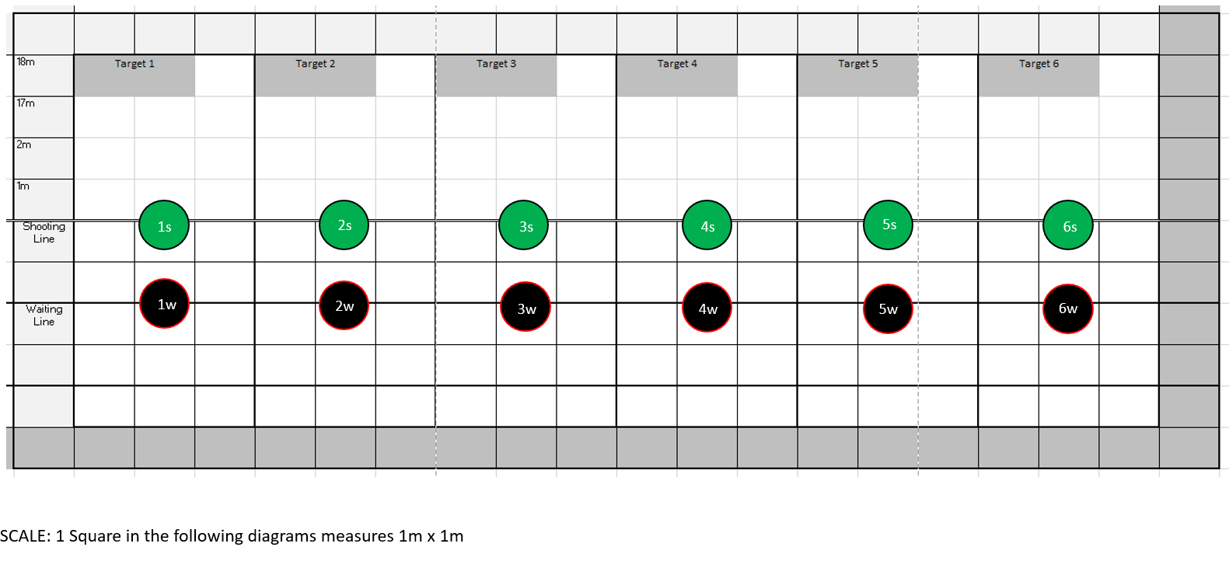
When run as a single Target Shooting line, the Athlete moves between their assigned Target Shooting position on the line, and the associated waiting position behind the line, using standard line control protocol. No additional signaling is required.
Similarly, when scoring, no changes need to be made for Physical Distancing, beyond what is done at the Target Shooting Line.

Appendix C: Target Range -- Double Target Shooting Line

Running a double line adds complexity to managing the line but allows approximately 2/3 of the number of Athletes that could be accommodated on a single line pre-COVID. For a double Target Shooting line, the lane setup will be the same as a single line but when operating in a double line, athletes will need to move to specific locations within the range and their Target Shooting line in order to maintain a 2m personal distance at all times.
The following diagram shows the range layout. Each Target Lane will consist of:
  - Three (3) individual Target Shooting lanes measuring a minimum of 1m wide: “A” Target Shooting lane, “B” Target Shooting lane, and a Buffer/Safety Lane.
  - Two (2) Transition Positions; 2m behind the Target Shooting line on the left and right border of the Target Lane.
  - One (1) Waiting Position; 4m behind the Target Shooting line in the center of the Target Lane
Some Transition Positions will be shared between adjacent Target Lanes. Athletes will need to take care to move only when their next position is clear. If the next position is not clear, they need to hold in place for a moment until the position is vacated and then move when it is safe. The amount of time they will be holding will be very short because the Transition Positions will not be occupied for any extended periods of time until it is time to collect arrows.

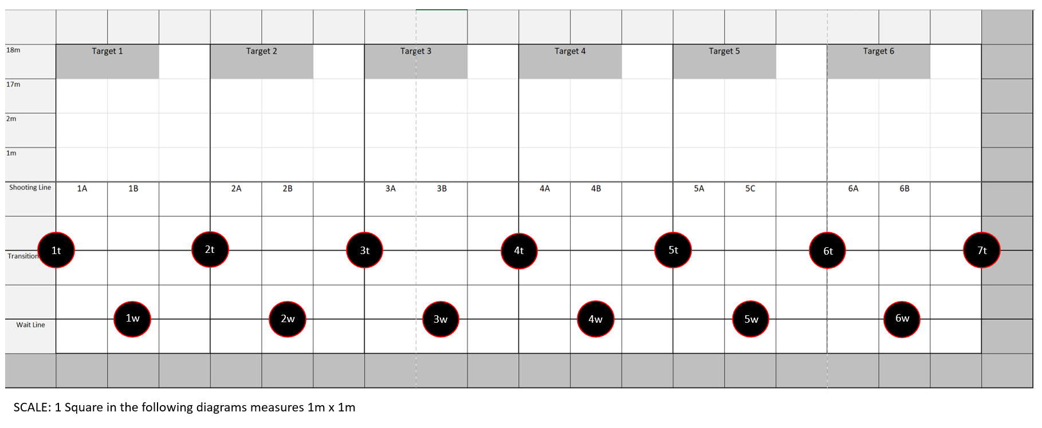

Target Shooting Procedure:
- Following Pre-Registration and before entering the field of play, athletes will be assigned a Target Lane (Number) and Target Shooting Lane (Letter).
- The following diagram shows the athletes in the “Ready to Shoot” position. This will indicate that the Range Officer can call the athletes to the line.

- Using standard protocol, the Range officer will call the Athletes to the line (2 whistles).
- Using standard protocol, the Range officer will signal that it is safe to shoot (1 whistle). Athlete A group will proceed to shoot their arrows.

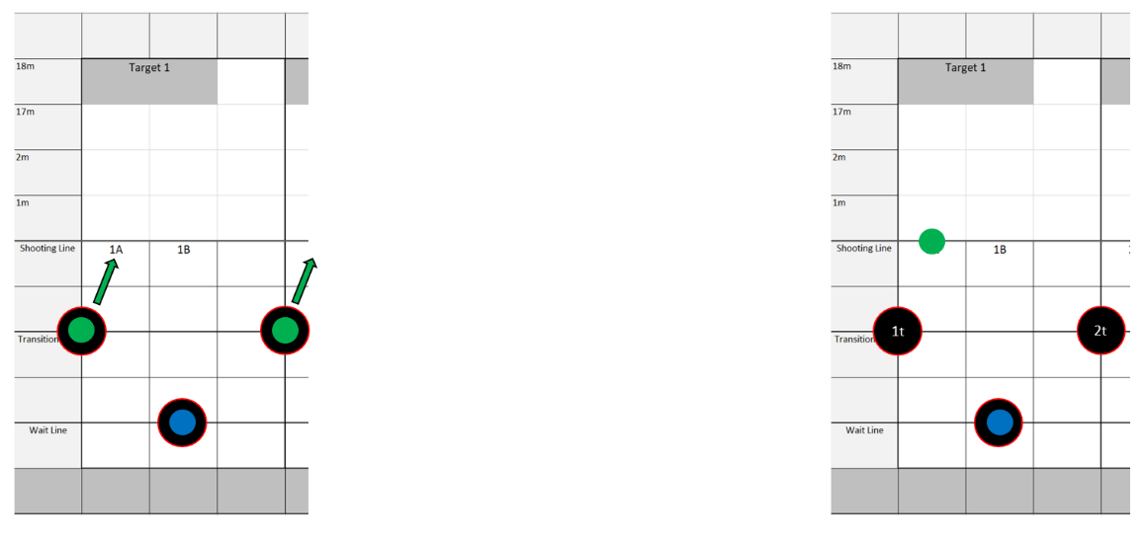
Note: To show movement as clearly as possible, the following diagrams will show only one Target Shooting lane.
- Athletes will finish Target Shooting at different times. As each Athlete is done Target Shooting, they will check to see if their designated Transition Position is clear. If it is clear then proceed to their Transition Position, the Athlete may move and if it is not clear they will hold until it is clear to move. In this case, Athlete 1A can move to their Transition Position because it is unoccupied.
- Once Athlete 1A is in the Transition Position, Athlete 1B can proceed to their Transition Position.

- Once Athlete 1B has reached their Transition Position, Athlete 1A can move to the Waiting Position. Following proper Target Shooting etiquette, Athlete 1B can proceed to the Target Shooting Line immediately.
- Upon arriving at their Target Shooting Position, Athlete B can proceed to shoot their arrows.

- Once Athlete B is done Target Shooting, they will check to see if their designated Transition Position is clear. Athlete B can move to their Transition Position if the following conditions are met:
  - If the Transition Position is open
  - If Athlete B from the adjacent Target Shooting lane has is not waiting and has begun to shoot.

- Once all athletes are in the All Clear Position, the Range Officer will signal that it is safe to collect arrows using standard protocol (3 whistles).
- Athletes will proceed to collect arrows. B Athletes will collect arrows first and A Athletes will collect after B Athletes are done. All Athletes must proceed through this phase maintaining 2m personal distance at all times.

An animation of this process is available at: https://youtu.be/RTcvmvOkFM4
Appendix D: Trap and Skeet Shooting
Trap Shooting can take place with no modification. Care will need to be taken to ensure physical distancing before, after and with cycling through the range. Common equipment (eg. trap House equipment and switches) will either be handled with gloves, wiped or sprayed between users.
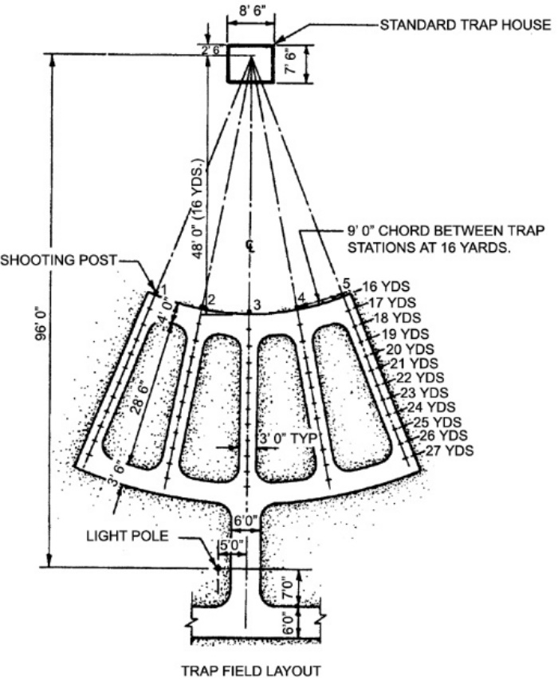
The Athletes are a minimum of 9’ apart at the 16-yard radius. This provides ample Physical Distancing.

Similarly, for Skeet, a single Athlete uses 8 stations. Adequate physical distancing is easily achieved:
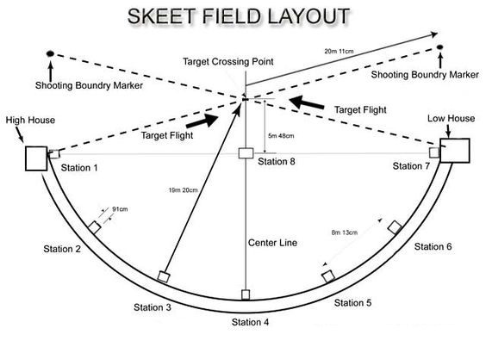

Appendix E: Silhouette Target Shooting
Silhouette Target Shooting follows the same procedures as target shooting. Accommodation for a spotter may be made, with the spotter keeping 2-meter distance from the Athletes – either directly behind the Athlete, or to one side, being careful of adjacent people.
A single line of Athletes is most appropriate, as a double line (see Target shooting section) will not work with the indicated spacing and spotters.
Silhouette Target Shooting often involves multiple relays. Athletes awaiting their relay should social distance away from the firing line area.
The flat bench area used as a firing point (e.g. to hold clip, timer, ammunition) should be disinfected once the Athlete leaves the firing line.
Targets will be painted or sprayed with a dilute bleach solution between relays.
All equipment (e.g. rifles and spotting scopes) will be disinfected upon completion of the practice.

Appendix F-1: Sample Sign in Sheet

Club |  | Location
Event |  | Date
Start Time |  | End Time

Staff Present
Name | Membership Number | Email | Phone

Athletes Present:
Name | Membership Number | Email | Phone

Spectators Present:
Name | Email | Phone

Notes:

Appendix F-2: Sample Sign in Sheet

Club Name:

This information is being collected to assist in the management of the COVID-19 pandemic.
It will be given to the Ministry of Health and/or Regional Health Authority on request if it is required for contact tracing purposes.
We will not use it for any other purpose and will destroy this record after four weeks. It will be kept in a safe and secure location in the meantime.
Date | Full Name | Address | Email | Phone | Time in | Time out

Appendix G: Sample Letter to Participants and Parents

We’re all anxious to get back to Target Shooting. We now have permission to do so, but we will need to take precautions to make sure everyone is safe. As a shooting sport, we always keep safety as our first priority. Starting up again, with COVID in the community, is no different.
We will be taking a Phased approach to reopening our sport that limits group size, maintains Physical Distancing, and minimizes physical contact. Initially, we will focus on Practice and skill development, not competition.
Changes you will see are:
- Do not come to the range is you are sick, or have any of the following symptoms:
  - Feeling unwell
  - Fever
  - Cough
  - Cold
  - Travel or contact with someone thought to have COVID in the past 14 days
- No drop-ins. Everyone must pre-register.
- Everyone must Sign In before starting practice. You will be assigned your lane at this time.
- You must keep at least 2 meters distance between you to anyone else.
- There will be no sharing of equipment between Athletes during a practice session.
- Use of club equipment will be limited to that which we can easily clean. You must wipe down, both before and after the session:
  - Your mat, if shooting prone
  - Your Rifle or Pistol, including magazines
  - Offhand Stands
  - Kneeling rolls
  - Any table or Bench
  - Any Target Shooting Aids
  - Any chairs used
- You must bring your own:
  - Eye Protection
  - Ear Protection
  - Hand Sanitizer
- Only 1 spectator will be allowed per Athlete, and only in the designated areas
- Movement and distancing while Target Shooting will be discussed during the safety briefing. These instructions must be strictly followed.
- You will be required to arrive and depart the range promptly. We will not be able to accommodate latecomers, and because of occupancy restrictions, you cannot remain at the range once you are finished Target Shooting.
- Any violation of these rules will result in you being asked to leave the range. This is a safety issue for you and everyone around you.
None of these new rules will affect our enjoyment of our sport. They are intended to keep us safe and get us back Target Shooting as soon as we safely can.

Appendix H: Sample Waiver

Acknowledgement of Risk & Waiver

This form is to be signed by all club members & also by a parent / guardian if a member is a youth

As with many sports there exists with Target Shooting an inherent risk of accident which may cause material loss or bodily injury. It is a condition of membership of ___________________________ Club that all members acknowledge & accept these risks & sign this waiver / release of liability.

In agreeing to allow myself / child / ward to partake in the activities of ___________________________ Club I fully acknowledge & accept that risks exist & that I on behalf of myself or as a parent / guardian accept these risks. I am fully aware of the possible risks involved in the sport of Target Shooting, and I agree to myself / my child / my ward partaking in the sport of Target Shooting. I am aware that I am encouraged to request any further information as I may feel is necessary to allow me to make an informed judgment as to the inherent risks.

Activity | Risks (may include but are not limited to)
Target Shooting | Possible death or other injury, including bruising, muscle damage, fatigue or strain, damage to eyesight. The action or inaction of other persons. Sunburn or other weather-related risks. Accident caused by inattention, or equipment failure. (if appropriate, add: Risk of contracting COVID-19 while participating in Target Shooting activities.)
I further understand & agree that:
The physical demands of the sport of Target Shooting require that I / my child / my ward be physically fit & able to participate in the club’s activities. I accept the assertion that instructors reserve the right to refuse me / my child / my ward to participate in the club activities for any reason.
To assist in instruction, it may be necessary on occasion for instructors to have limited physical contact with me, my child / ward.

Please advise any medical condition / allergy you / your child may have – in the unlikely event of an accident medical personnel may require this information.

Medical Conditions / Allergies: ____________________________________________________

- I confirm that I have read the above and fully understand & freely accept the type of activity that I / my child / my ward will be participating in, and the inherent risks associated with those activities.
- I freely accept responsibility for myself / my child / my ward & agree to hold harmless & free of blame ___________________________ Club, its Officers, Directors, Coaches & assistants.
- I waive my right to institute legal action associated with bodily injury occasioned whilst engaged in club activities against ___________________________ Club. Its Officers, Directors, Coaches & assistants.
- I accept that this waiver & release is binding upon me & upon my heirs, next of kin, executors, administrators, personal representatives & assigns.
- I sign & accept this waiver & release voluntarily & without pressure.
- I hereby agree to myself / my child / my ward taking part in Target Shooting activities associated with ___________________________ Club.
- I have read the athletes code of conduct and understand that my membership may be terminated at the discretion of the ___________________________ club board members should I fail to follow this code of conduct.

Signature of Participant:_______________________Print Name:___________________________

(If participant is under 18)
Signature of Parent / Guardian:________________________Print Name: ________________________

Dated: (day) _______ (month) ___________ 20___

Abbreviations
BCTSA – British Columbia Target Sports Association
PPE – Personal Protective Equipment
PSO – Provincial Sports Organization

